Tom Stoppard’s
The Real Thing
Directed by Dan Dryer
16th – 19th September 2026
Barn Theatre, Southwick Community Centre, Southwick Street, Southwick BN42 4TE
The Real Thing by Tom Stoppard premiered at the Strand Theatre, London in 1982, winning the Evening Standard Award for Best Play.
The play begins with Max and Charlotte, a couple whose marriage is on the verge of ending. But nothing one sees on stage is the real thing, and some things are less real than others. Charlotte is in a play written by her husband Henry. Max, her leading man, is also married to an actress Annie. Both marriages are in trouble because Henry and Annie have fallen in love. But is it the real thing?
What is this thing called love? In The Real Thing, we watch Henry find the answer.
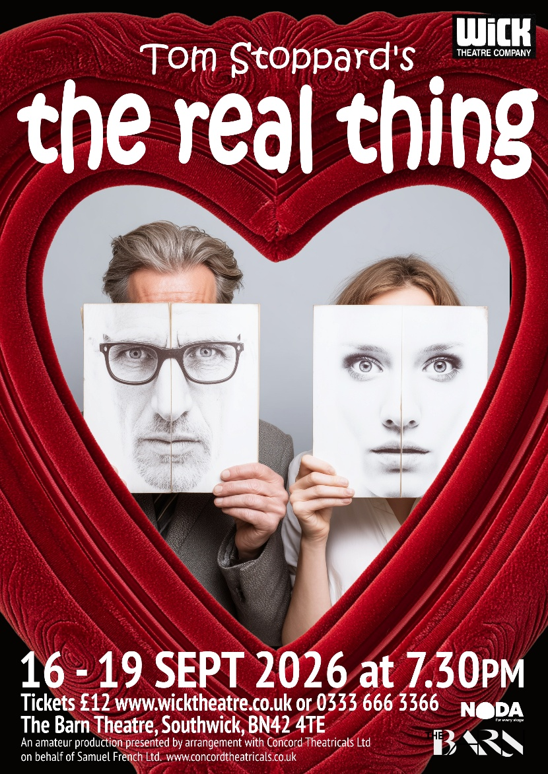
Characters
Smaller roles are all important and well drawn out characters with their own meaty scenes. Playing ages are flexible and will depend on casting of other roles.
Henry
Forties
Annie
Thirties
Charlotte
Mid-thirties
Max
Forties
Billy (has to be able to act a convincing Scottish accent), smaller role 3 scenes
Early twenties
Debbie, smaller role 1 scene
Seventeen
Brodie (Scottish accent essential), smaller role 1 scene
Mid-twenties
Show Launch and Auditions
Sunday 10th May 2026 at 2pm.
If you are unable to make this date, please contact director Dan Dryer directly at dandryer123@hotmail.com to arrange another time to audition.
Rehearsals will be held on Monday, Tuesday and Thursday evenings. However you will not need to be available for all three evenings every week. There will be some Sunday rehearsals later in the rehearsal run.
Rehearsals will start on Monday 15th June 2026.
Fees
You do not need to be a member of the Wick Theatre Company to audition, however if you are cast you will need to join. There is a membership fee of £25 a year (concessions £15). This will include your script and there is no show fee.

Audition Slip
Name: | Mobile:
Email:
Reading for the role(s) of:
Are you willing to play as cast?
Any days you cannot regularly rehearse:

Details of holidays booked of other commitments:
Is there anything else the Director needs to know?
Photography and Filming: Adults
During the course of our process there will be film and photography for publicity purposes.

Could you please read and sign the relevant declaration below:

I give / do not give* permission for photographs or film to be taken for publicity purposes

Print Name: ______________________________________________________

Signed: _______________________________Date: ______________________

* delete as appropriate

Audition Pieces
Henry
Speech 1
Shut up and listen. This thing here, which looks like a wooden club, is actually several pieces of particular wood cunningly put together in a certain way so that the whole thing is sprung, like a dance floor. It's for hitting cricket balls with. If you get it right, the cricket ball will travel two hundred yards in four seconds, and all you've done is give it a knock like knocking the top off a bottle of stout, and it makes a noise like a trout taking a fly ... (he clucks his tongue to make the noise). What we're trying to do is to write cricket bats, so that when we throw up an idea and give it a little knock, it might ... travel... (he clucks his tongue again and picks up the script). Now, what we've got here is a lump of wood of roughly the same shape trying to be a cricket bat, and if you hit a ball with it, the ball will travel about ten feet and you will drop the bat and dance about shouting 'Ouch!' with your hands stuck into your armpits (indicating the cricket bat). This isn't better because someone says it's better, or because there's a conspiracy by the MCC to keep cudgels out of Lords. It's better because it's better. You don't believe me, so I suggest you go out to bat with this and see how you get on. 'You're a strange boy, Billy, how old are you?’ ‘Twenty, but I've lived more than you'll ever live.’ Ooh, ouch!
Speech 2
It's to do with knowing and being known. I remember how it stopped seeming odd that in biblical Greek knowing was used for making love. Whosit knew so-and-so. Carnal knowledge. It's what lovers trust each other with. Knowledge of each other, not of the flesh but through the flesh, knowledge of self, the real him, the real her, in extremis, the mask slipped from the face. Every other version of oneself is on offer to the public. We share our vivacity, grief, sulks, anger, joy ... we hand it out to anybody who happens to be standing around, to friends and family with a momentary sense of indecency perhaps, to strangers without hesitation. Our lovers share us with the passing trade. But in pairs we insist that we give ourselves to each other. What selves? What's left? What else is there that hasn't been dealt out like a deck of cards? A sort of knowledge. Personal, final, uncompromised. Knowing, being known. I revere that. Having that is being rich, you can be generous about what's shared - she walks, she talks, she laughs, she lends a sympathetic ear, she kicks off her shoes and dances on the tables, she's everybody's and it don't mean a thing, let them eat cake; knowledge is something else, the undealt card, and while it's held it makes you free-and-easy and nice to know, and when it's gone everything is pain. Every single thing. Every object that meets the eye, a pencil, a tangerine, a travel poster. As if the physical world has been wired up to pass a current back to the part of your brain where imagination glows like a filament in a lobe no bigger than a torch bulb. Pain.

Annie
Annie You're jealous of the idea of the writer. You want to keep it sacred, special, not something anybody can do. Some of us have it, some of us don't. We write, you get written about. What gets you about Brodie is he doesn't know his place. You say he can't write like a head waiter saying you can't come in here without a tie. Because he can't put words together. What's so good about putting words together?

Henry It's traditionally considered advantageous for a writer.

Annie He's not a writer. He's a convict. You're a writer. You write because you're a writer. Even when you write about something, you have to think up something to write about just so you can keep writing. More well-chosen words nicely put together. So what? Why should that be it? Who says?

Henry Nobody says. It just works best.

Annie Of course it works. You teach a lot of people what to expect from good writing, and you end up with a lot of people saying you write well. Then somebody who isn't in on the game comes along, like Brodie, who really has something to write about, something real, and you can't get through it. Well, he couldn't get through yours, so where are you? To you, he can’t write. To him, write is all you can do.

Charlotte
Charlotte There's something touching about you, Henry. Everybody should be like you. Not interested. It used to bother me that you were never bothered. Even when I got talked into that dreadful nudie film because it was in Italian and Italian films were supposed to be art... God, that dates me, doesn't it? Debbie's into Australian films. Australian.

Henry You've gone off again.

Charlotte Yes, well, it didn't bother you so I decided it meant you were having it off right left and centre and it wasn't supposed to matter. By the time I realised you were the last romantic it was too late. I found it didn't matter.

Henry Well, now that it doesn't ... How many – um – roughly how many?

Charlotte Nine.

Pause.

Henry Gosh.

Charlotte And look what your one did compared to my nine.

Henry Nine?

Charlotte Feel betrayed?

Henry Surprised. I thought we'd made a commitment.

Charlotte There are no commitments, only bargains. And they have to be made again every day. You think making a commitment is it. Finish. You think it sets like a concrete platform and it'll take any strain you want to put on it.
You're committed. You don't have to prove anything. In fact you can afford a little neglect, indulge in a little bit of sarcasm here and there, isolate yourself when you want to. Underneath it's concrete for life. I'm a cow in some ways, but you're an idiot. Were an idiot.

Henry Better luck next time.

Charlotte You too.
Have a drink?

Henry I don't think so, thank you.
How are things with your friend? An architect, isn't he?

Charlotte I had to give him the elbow. Well, he sort of left. I called him the architect of my misfortune.

Henry What was the matter with him?

Charlotte Very possessive type. I came home from a job, I'd been away only a couple of days, and he said, why did I take my diaphragm? He'd been through my bathroom cabinet, would you believe? And then, not finding it, he went through everything else. Can't have that.

Henry What did you say?

Charlotte I said, I didn't take my diaphragm, it just went with me. So he said, what about the tube of Duragel? I must admit he had me there.

Max
Lake Geneva. You haven't been to Virginia Water, have you? Lake Geneva. It is at Geneva? It must be. They wouldn't call it Lake Geneva if it was at Ba'l or Basel. They'd call it Lake Ba'l or Basel. You know the Swiss. Utterly reliable. And they've done it without going digital, that's what I admire so much. They know it's all a snare and a delusion. I can remember digitals when they first came out. You had to give your wrist a vigorous shake like bringing down a thermometer, and the only place you could buy one was Tokyo. But still the Swiss didn't panic. In fact, they made a few digitals themselves, as a feint to draw the Japanese further into the mire, and got on with numbering the bank accounts. And now you see how the Japanese are desperately putting hands on their digital watches. It's yodelling in the dark. They can yodel till the cows come home. The days of the digitals are numbered. Digitals have got no class, you see. They're science and technology. Makes nonsense of a decent pair of cufflinks, as the Swiss are the first to understand. Good sale?

Charlotte stares at him.

Charlotte What?

He affects surprise.

Max Good sale. Was the sale good? The sale in Geneva, how was it? Did it go well in Geneva, the sale?

Charlotte What's the matter?

Max I'm showing an interest in your work. I thought you liked me showing an interest in your work. My showing. Save the gerund and screw the whale. Yes, I'm sure you do. I remember how cross you got when I said to someone, 'My wife works for Sotheby's or Christie's, I forget which.’ You misjudged me, as it happens. You thought I was being smart at your expense. In fact, I had forgotten. How's old Christie, by the way? (Strikes his forehead). There I go. How's old Sothers, by the way? Happy with the Geneva sale, I trust?

Charlotte puts her glass down and moves to stand facing him.

Charlotte (to call a halt) All right.

Max Just all right? Well, that's the bloody Swiss for you. Conservative, you see. The Japanese could show them a thing or two. They'd have a whaling fleet in Lake Geneva by now. How's the skiing, by the way? Plenty of snow?

Charlotte Stop it - stop it - stop it.
What have I done?

Max You forgot your passport.

Charlotte I did what?

Max You went to Switzerland without your passport.

Charlotte What makes you think that?

Max I found it in your recipe drawer.

Charlotte (quietly) Jesus God.

Max Quite.

Billy
Annie I'm a lot older. I'm going to look more like your mother than your sister.

Billy That's all right, so long as it's incest. Anyway, I like older women.

Annie Billy, you mustn't keep flirting with me.

Billy Why not?

Annie Well, because there's no point. Will you stop?

Billy No. Is that all right?

Pause.

Annie Did you know I was going to be on this train?

Billy (nods) Watched you get on. I thought I'd come and find you when it got started.

Annie You certainly thought about it.

Billy I had to wait until the inspector came round. I haven't got a first-class ticket.

Annie What will you do if he comes back?

Billy I'll say you're my mum. How come you get a first-class ticket?

Annie I don't really. I'm afraid I upped it myself.

Billy You approve of the class system?

Annie You mean on trains or in general?

Billy In general. Travelling first-class.

Annie There's no system. People group together when they've got something in common. Sometimes it's religion and sometimes it's, I don't know, breeding budgies or being at Eton. Big and small groups overlapping. You can't blame them. It's a cultural thing; it's not classes or system. (She makes a connection.) There's nothing really there - it's just the way you see it. Your perception.

Billy Bloody brilliant. There's people who've spent their lives trying to get rid of the class system, and you've done it without leaving your seat.

Annie Well...

Billy The only problem with your argument is that you've got to be travelling first-class to really appreciate it.

Annie I...

Billy Where do you get all that from? Did you just make it up? It's daft. I prefer Brodie. He sounds like rubbish, but you know he's right. You sound all right, but you know it's rubbish.

Annie Why won't you do his play, then?

Billy I didn't say I wouldn't. I'll do it if you're doing it.

Annie You shouldn't do it for the wrong reasons.

Billy Why not? Does he care?

Annie You said he can't write.

Billy He can't write like your husband. But your husband's a first-class writer.

Annie Are you being nasty about Henry?

Billy No. I saw House of Cards. I thought it was quite good.

Annie He'll be relieved to hear that.

Pause.

Billy Don't go off me.

Debbie
Henry Didn't you like the last one?

Debbie What, House of Cards? Well, it wasn't about anything, except did she have it off or didn't she? What a crisis. Infidelity among the architect class. Again.

Henry It was about self-knowledge through pain.

Debbie No, it was about did she have it off or didn't she. As if having it off is infidelity.

Henry Most people think it is.

Debbie Most people think not having it off is fidelity. They think all relationships hinge in the middle. Sex or no sex. What a fantastic range of possibilities. Like an on/off switch. Did she or didn't she. By Henry Ibsen. Why would you want to make it such a crisis?

Henry I don't know, why would I?

Debbie It's what comes of making such a mystery of it. When I was twelve I was obsessed. Everything was sex. Latin was sex. The dictionary fell open at meretrix, a harlot. You could feel the mystery coming off the word like musk. Meretrix! This was none of your mensa-a-table, this was a flash from the forbidden planet, and it was everywhere. History was sex, French was sex, art was sex, the Bible, poetry, penfriends, games, music, everything was sex except biology which was obviously sex but obviously not really sex, not the one which was secret and ecstatic and wicked and a sacrament and all the things it was supposed to be but couldn't be at one and the same time - I got that in the boiler room and it turned out to be biology after all. That's what free love is free of - propaganda.

Brodie

Brodie Billions of pounds for defence, nothing left for prisons. So you get three, four to a cell. First off, they tell the magistrates, for God's sake go easy, fine the bastards. But still they keep coming - four, five to a cell. Now they're frightened it's going to blow up. Even the warders are going on strike. So: 'Give us the money to build more prisons!' ‘Can't be done, laddie, we're spending the money to keep the world free, not in prison.’ So they start freeing the prisoners. Get it? I'm out because the missiles I was marching against are using up the money they need for a prison to put me in. Beautiful. Can I have another?

He holds up his empty glass for Annie. Slight pause. Henry stays still.

Annie Please help yourself

Brodie does so.

Brodie Early release. There was eight of us just on my corridor. (to Henry) Not one of them a controversial TV author. I don't owe you.

Henry Is it against your principles to say thank you for anything, even a drink?

Brodie Fair enough. You had a go. You did your best. It probably needed something, to work in with their prejudices.

Henry Yes, they are a bit prejudiced, these drama producers. They don't like plays which go 'clunk' every time someone opens his mouth. They gang up against soap-box bigots with no idea that everything has a length. They think TV is a visual medium. (to Annie, puzzled) Is this him?

Brodie Don't be clever with me, Henry, like you were clever with my play. I lived it and put my guts into it, and you came along and wrote it clever. Not for me. For her. I'm not stupid.

Annie (to Henry) No, this isn't him.

Brodie Yes, it bloody is. That was me on the train, and this is me again, and I don't think you're that different either.

